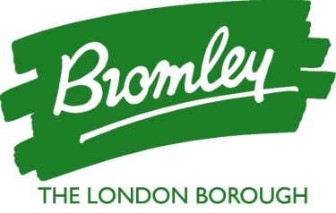 | Public Health  Civic Centre, Stockwell Close, Bromley, BR1 3UH  Telephone: 020 8464 3333  Internet: www.bromley.gov.uk  Email: Nada.Lemic@bromley.gov.uk  Email (Admin Support): Cassandra.Hedges@bromley.gov.uk
May 2021

Dear Parent or Carer,

We are aware that some children are attending school when their parents are self-isolating because of Covid infection. This letter is a reminder that children should not be in school if their parents are self-isolating due to Covid infection, even if both the parents and the child have no symptoms and feel well.

At least a third of cases of Covid have no symptoms, which is why staff in all schools, and students in secondary stage education continue to self-test twice a week.

Continued testing twice a week and reporting a test result is a crucial part of our fight against COVID-19 so that we understand the amount of Covid circulating in the school community. Students should share positive results with their school so that, if positive, immediate contact tracing can take place both in school and beyond the school environment.

If anyone in your household tests positive (whether symptomatic or not), you will all be legally required to isolate at home for ten days from the date of your positive test (or onset of symptoms if sooner), along with any recent close contacts. Isolating at home means that you are not allowed out for any reason, even for exercise for yourself or a pet.

You are legally required to isolate for the full ten days, even if you are not displaying symptoms.

You will be asked to complete an NHS Test and Trace questionnaire with information about your activities and contacts: https://contact-tracing.phe.gov.uk. This only takes a short time to complete but is vital in helping us to stop the spread of COVID-19. Completing this questionnaire online will avoid having to do so over the phone with the national Test and Trace team.

We recognise that isolating for 10 days is difficult for some families, and there is support available for self-isolating families (see attached sheet)

Thank you very much for helping to keep us all safe.

Yours sincerely

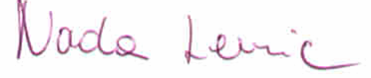

Dr Nada Lemic
Director of Public Health

