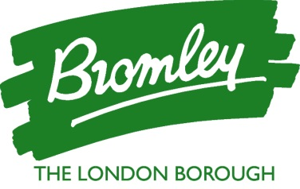
Parent Letter Appendix

Support for Self-Isolating families

If you think you may have difficulties in accessing food, medicine, money, or even just someone to talk to if you are lonely, Bromley Council is here to help.

Order your shopping by Phone

If you are unable to access online shopping, Morrison’s supermarket offers a telephone ordering service to enable you to access all food and essential items. You will require a debit or credit card to pay. Please call Morrison’s on 0345 611 6111 and select option 5 to place your order. Alternatively, Sainsburys can be contacted on 0800 917 8557. Both supermarkets will then deliver shopping to your home address.

Accessing Prescription Medicines

The medicines delivery service is for prescription medication only and will be available during your 10-day self-isolation period where no alternatives are available - in the first instance, you should ask if any friends or family outside of your household can collect medicines for you. You will need to call your local pharmacy or dispensing doctor and provide your unique contact tracing reference number in order to arrange delivery of your medicine. For further information please visit: https://www.england.nhs.uk/coronavirus/publication/preparedness-letters-for-community-pharm

Accessing Self-Isolation Support Payments

If you are on a low income and are in receipt of benefits, you may be eligible for a £500 self-isolation support payment. To check if you are eligible and to apply, please visit our website:
www.bromley.gov.uk/covid-19

Support from a Volunteer with a friendly regular phone call

Bromley Council, in partnership with Community Links Bromley, has a free of charge befriending service in place to ensure all of our residents can find a friend to talk to, if needed. If you would like support from a volunteer with a regular friendly phone call, please call our assistance line on 020 8313 4484 Monday to Friday, 8:30am to 5:30pm and we will match you with a local volunteer.

Help is also available by completing the online assistance form on our Covid-19 page (or asking a friend or family member to do so for you) at www.bromley.gov.uk/COVID-19.

Accessing free food support from a food bank

If you are having difficulty paying for food, one of the food banks located in the borough will be able to help you. Visit www.bromley.gov.uk/covid-19 for details of locations.

